


All Saints CE First School

Loving and learning with Jesus
“Let your light shine before you”
Matthew 5:16

Nursery Admissions Arrangements 2026 - 2027

Our Vision

Loving and learning with Jesus
“Let your light shine before you”
Matthew 5:16
As a Church of England school and a member of the Innovate2Educate Partnership, the teachings of Jesus and our Christian Values are at the heart of all we do, our children and staff serve with courage, compassion, aspiration and hope to live life in all its fullness allowing them to flourish and shine.

Our Mission
- FAITH: Providing an environment where Christian values underpin all we do, where worship flows into our learning and where all children appreciate the value of other faiths whilst being rooted in a Christian community. Trust

- LEARNING: Achieving high standards in learning by identifying and providing for the needs and talents of each pupil to enable them to achieve their potential. Service

- OPPORTUNITY: Providing opportunities for pupils to be curious, creative and inspired by taking part in a range of educational experiences, visits and extra-curricular activities. Courage

- UNDERSTANDING: Establishing a caring community which recognises equality of opportunity, diversity and raises awareness of moral values within a Christian ethos. Compassion

- RESPECT: Promoting high standards of behaviour and fostering a sense of respect and responsibility for self and others. Respect

- INDEPENDENCE: Helping children develop a range of skills to be confident and self-assured learners with excellent attitudes to learning. Generosity

- SELF-MOTIVATION: Fostering self-reliance, so that pupils enjoy the challenge of learning and are resilient to failure. Perseverance

- HAPPINESS: Creating a safe, nurturing and stimulating learning environment in which children can flourish. Friendship

ADMISSION ARRANGEMENTS FOR ALL SAINTS CE FIRST SCHOOL NURSERY PART OF INNOVATE2EDUCATE PARTNERSHIP
Designated Nursery Provision: Academic Year 2026-27

Designated Nursery Provision
It is the Academy Trust’s policy to try and meet parents’ wishes where possible, however in some cases there may be more applications for the Nursery than there are places. Admission to this setting is determined by the oversubscription criteria detailed below.

Oversubscription Criteria
If the total number of preferences for admission to a nursery age setting exceeds the number of available places, then the following order of priority will be used to allocate the available places.
1) Looked After Children (LAC), Previously Looked After Children (PLAC) and including Internationally Adopted Previously Looked After Children (IAPLAC) please see Appendix 2
2) Children who satisfy both of the following tests:

Test 1: the child is distinguished from the great majority of other applicants either on their own individual medical grounds or by other exceptional circumstances.
Medical grounds must be supported by a medical report (obtained by the applicant and provided at the point of application). This report must clearly justify, for health reasons only, why it is better for the child’s health to attend the All Saints CE First School Nursery rather than any other nursery.
Exceptional circumstances must relate to the choice of nursery and the individual child, i.e. the circumstances of the child, not the specific economic or social circumstances of the parent/carer, and be supported by a professional report (obtained by the applicant and provided at the point of application), e.g. social worker, justifying why it is better for the child to attend the All Saints CE First School Nursery rather than any other nursery.
And
Test 2: the child would suffer hardship if they were unable to attend the All Saints CE First School Nursery.
Hardship means severe suffering of any kind, not merely difficulty or inconvenience, which is likely to be experienced as a result of the child attending a different school. Applicants must provide detailed information about both the type and severity of any likely hardship at the time of application.

3) Children who have an elder brother or sister in attendance at the school and who will still be attending the school at the time of the proposed admission date. (For admission purposes, a brother or sister is a child who lives at the same address and either: have one or both natural parents in common; are related by a parent’s marriage; are adopted or fostered by a common parent or are unrelated children who live at the same address, whose parents live as partners.)
4) Children living within the defined catchment area. Cluster areas for nursery age settings will sometimes, but not always, correspond to the catchment area for the main school. Please see Appendix 1.
5) Other children arranged in order of priority according to how near their home addresses are to the main gate of the nursery setting, determined by a straight-line measurement as calculated using the Local Authority’s Geographical Information System.

Where it is not possible to accommodate all children applying for places within a particular category then the Academy will allocate the available places in accordance with the remaining criteria. If for instance, all the catchment area or cluster area children cannot be accommodated at a school, children who are resident within the catchment or cluster area will be arranged in order of priority according to the remaining criteria.

Applications for All Saints CE Nursery are processed by the school/academy.
- It is important to note that attendance/enrolment in the Nursery will be distinct and separate and have no relevance to attendance in Reception or other sections of the Academy for which a separate application will have to be made in accordance with the Academy’s admission arrangements. No appeal will be allowed against the refusal of a place in the Nursery.
- Oversubscription – If the Nursery is oversubscribed, priority will be given to children with Statements of Special Educational Needs or Education and Health Care Plans where the academy is named. The remaining places will then be offered in accordance with the oversubscription criteria which applies to the Academy Trust as a whole, except that sibling priority will only apply where a sibling already attends the Academy Nursery or school.
iii. Waiting list – The Nursery will keep a waiting list which will be used to fill casual vacancies occurring as a result of an enrolled child leaving during the academic year or withdrawing from a place that has been offered. The list will be compiled in accordance with the Admissions Code so that children will be ranked in line with the Academy Trust’s oversubscription criteria.

Applicants will be placed on a waiting list in accordance with the oversubscription criteria stated above and not based on the date their application was received. There will be a period of two weeks after the published offer date whereby available places will not be reallocated. If places become available after this date they will be
offered according to the child at the top of the waiting list. Waiting lists will be kept until the end of the Autumn term of admission.
Inclusion on the waiting list does not mean that a place will eventually become available in the Nursery.
A child’s position on a waiting list is not fixed and is subject to change during the year, i.e. they can go up or down the list since each added child will require the list to be ranked again in line with the oversubscription criteria.

There is no statutory right of appeal for admission to a nursery setting. Any disputes over the administration of the policy will be dealt with by Innovate2Educate Partnerships complaints procedure.

Nursery Provision (15-30 hours funded places are available at All Saints Nursery)
Funded Places
All 3 to 4-year-olds in England are entitled to 570 free childcare hours per year. It is usually taken as 15 hours a week for 38weeks of the year.
Some 3 to 4-year-olds are eligible for 30 hours free childcare a week. For full information and to check eligibility visit the GOV.UK webpage: www.gov.uk/apply-30-hours-free-tax-free-childcare.
If a child is eligible for 30 hours funding parents will be issued with a code from HMRC to pass to the setting.
All parents are obliged to complete a 'parent declaration early education funding (EEF) form, this form will need to be completed prior to the child starting at the setting and re-signed prior to the start of each term.
If funded hours taken or eligibility changes in-year, the parental declaration form will need to be amended to reflect this when re-signed each term.
The 15 & 30 hours funding does not cover the cost of lunch and any additional sessions taken in addition to funded hours are chargeable at the settings current rates.
Please note that refunds are not made for missed sessions from funded hours.

Approved by the Board of Trustees on behalf of the schools Governing Body: 12th March 2025

Appendix 1.

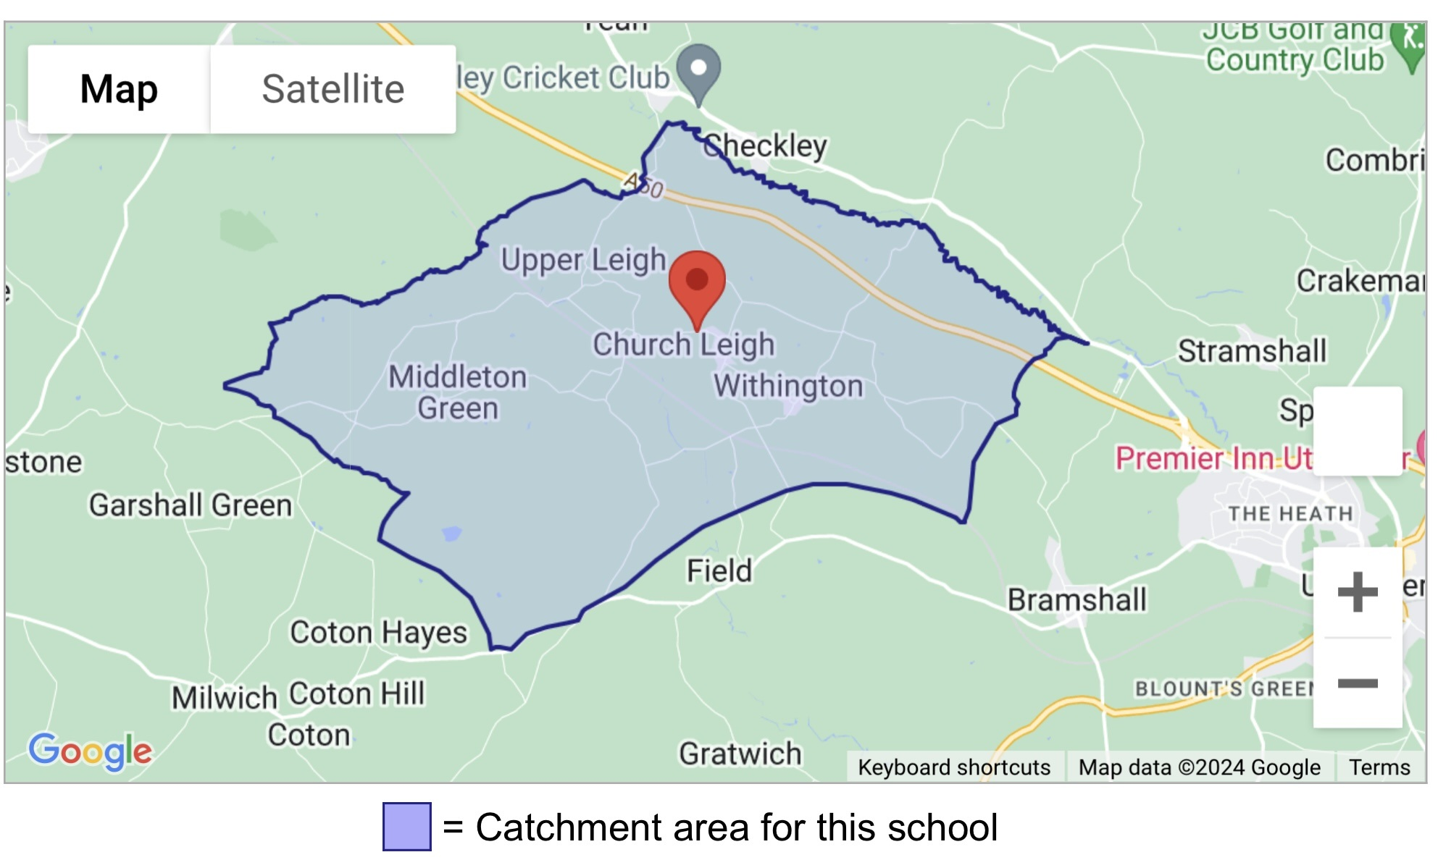
The home address is considered to be the child’s along with their parent/carer’s main and genuine principal place of residence at the time of the allocation of places i.e. where they are normally and regularly living. If a child is resident with friends or relatives (for reasons other than legal guardianship) the friends or relatives address will not be considered for allocation purposes.
If a child’s home address changes during the admissions process it is the responsibility of the parent/carer to inform the Academy immediately. Where there is a proposed house move taking place during the admissions process the Academy will only accept the revised address for purposes of allocation where parents/carers can provide documentary evidence of the move by 1 week before the closing date. It will be necessary for sufficient evidence of a permanent move to be provided by the applicant by this date before it will be taken into account for allocation purposes on the offer date.
If a place is offered on the basis of an address that is subsequently found to be different from the child’s normal and permanent home address at the time of allocation of places then that place is likely to be withdrawn.

Where parents have shared responsibility for a child, and the child lives with both parents for part of the school week, parents will be required to provide documentary evidence to support the address they wish to be considered for allocation purposes.
It is expected that parents will agree on Nursery places before an application is made, and it may be necessary to request evidence from you to confirm that this is the case. The Academy is not in a position to intervene in disputes between parents over Nursery applications and will request that these are resolved privately.
If there are a limited number of spaces available and we cannot distinguish between applicants using the criteria listed, such as in the case of children who live in the same block of flats or are the result of a multiple birth, then the child or children who will be offered the available spaces will be randomly selected. This process will be independently verified.

Appendix 2
A 'looked after child' or a child who was previously looked after but immediately after being looked after became subject to an adoption, child arrangements, or special guardianship order including those who appear [to the admission authority] to have been in state care outside of England and ceased to be in state care as a result of being adopted. A looked after child is a child who is (a) in the care of a local authority, or (b) being provided with accommodation by a local authority in the exercise of their social services functions (see the definition in Section 22(1) of the Children Act 1989).

Looked after children means children who are looked after by a local authority in accordance with section 22 (1) of the Children Act 1989 and who is (a) in care of a local authority, or (b) being provided with accommodation by a Local Authority in the exercise of their social services functions (see definition in Section 22 (1) of the Children Act 1989) at the time of making an application to a school. This includes children who were adopted under the Adoption Act 1976 (see section 12 adoption orders) and children who were adopted under Adoption and Children Act 2002 (see section 46 adoption orders). Child arrangements orders are defined in s.8 of the Children Act 1989, as amended by s.12 of the Children and Families Act 2014. Child arrangements orders replace residence orders and any residence order in force prior to 22 April 2014 is deemed to be a child arrangements order. Section 14A of the Children Act 1989 defines a special guardianship order as an order appointing one or more individuals to be a child’s special guardian (or special guardians). It is the applicant’s responsibility to provide any supportive information required in order for the application to be assessed against the published admissions criteria, the school will not seek to obtain this information on behalf of the applicant.

