


All Saints CE First School

Loving and learning with Jesus
“Let your light shine before you”
Matthew 5:16

Admissions Policy 2026 - 2027

Our Vision

Loving and learning with Jesus
“Let your light shine before you”
Matthew 5:16
As a Church of England school and a member of the Uttoxeter Learning Trust, the teachings of Jesus and our Christian Values are at the heart of all we do, our children and staff serve with courage, compassion, aspiration and hope to live life in all its fullness allowing them to flourish and shine.

Our Mission
- FAITH: Providing an environment where Christian values underpin all we do, where worship flows into our learning and where all children appreciate the value of other faiths whilst being rooted in a Christian community. Trust

- LEARNING: Achieving high standards in learning by identifying and providing for the needs and talents of each pupil to enable them to achieve their potential. Service

- OPPORTUNITY: Providing opportunities for pupils to be curious, creative and inspired by taking part in a range of educational experiences, visits and extra-curricular activities. Courage

- UNDERSTANDING: Establishing a caring community which recognises equality of opportunity, diversity and raises awareness of moral values within a Christian ethos. Compassion

- RESPECT: Promoting high standards of behaviour and fostering a sense of respect and responsibility for self and others. Respect

- INDEPENDENCE: Helping children develop a range of skills to be confident and self-assured learners with excellent attitudes to learning. Generosity

- SELF-MOTIVATION: Fostering self-reliance, so that pupils enjoy the challenge of learning and are resilient to failure. Perseverance

- HAPPINESS: Creating a safe, nurturing and stimulating learning environment in which children can flourish. Friendship

All Saints CE First School Part of Innovate2Educate Partnership

Admissions Policy September 2026-27

Admission Limits
All Saints First School’s published admission number (PAN) is 12.
To comply with class size legislation there will be a maximum of 30 children in KS1 Classes.
The normal point of entry for admission to All Saints CE First School is Reception, where upon full time places will be available in the September of the academic year in which the child turns 5 years old.

Catchment Area: The catchment area of the school is the Parish of Leigh. See Appendix 1.

Admissions Criteria
If the number of applications for admission to the school exceeds the Published Admission Number (PAN), the following order of priority is used to allocate the available places. In accordance with legislation, children who have a statutory statement of special educational need, or Education, Health and Care Plan that names the school must be admitted. This will reduce the number of places available to other applications Paragraph 1.6 of the code

1) Looked After Children (LAC), Previously Looked After Children (PLAC) and including Internationally Adopted Previously Looked After Children (IAPLAC) Please see Appendix 2.
2) Children who satisfy both of the following tests:

Test 1: the child is distinguished from the great majority of other applicants either on their own individual medical grounds or by other exceptional circumstances.
Medical grounds must be supported by a medical report (obtained by the applicant and provided at the point of application). This report must clearly justify, for health reasons only, why it is better for the child’s health to attend the All Saints CE First School rather than any other school.
Exceptional circumstances must relate to the choice of school and the individual child, i.e. the circumstances of the child, not the specific economic or social circumstances of the parent/carer, and be supported by a professional report (obtained by the applicant and provided at the point of application), e.g. social worker, justifying why it is better for the child to attend the All Saints CE First School rather than any other school.
And
Test 2: the child would suffer hardship if they were unable to attend the All Saints CE First School.
Hardship means severe suffering of any kind, not merely difficulty or inconvenience, which is likely to be experienced as a result of the child attending a different school. Applicants must provide detailed information about both the type and severity of any likely hardship at the time of application.

3) Children who have an elder brother or sister in attendance at the school and who will still be attending the school at the time of the proposed admission date. (For admission purposes, a brother or sister is a child who lives at the same address and either: have one or both natural parents in common; are related by a parent’s marriage; are adopted or fostered by a common parent or are unrelated children who live at the same address, whose parents live as partners.)
4) Children living within the defined catchment area.
5) Other children arranged in order of priority according to how near their home addresses are to the main gate of the school setting, determined by a straight-line measurement as calculated using the Local Authority’s Geographical Information System.

Where it is not possible to accommodate all children applying for places within a particular category then the Academy will allocate the available places in accordance with the remaining criteria. If for instance, all the catchment area or cluster area children cannot be accommodated at a school, children who are resident within the catchment or cluster area will be arranged in order of priority according to the remaining criteria.

Admission of Reception Age Children
All pupils are admitted at the beginning of the school year following their fourth birthday.

Admissions Procedure
In response to a request for a place for a child at All Saints CE First School, Parents will be sent the following: -
- Information containing the admission criteria. Applications are to be made via: staffordshire school admissions. Alternatively, a late application can be made by paper, obtained from the school office or downloaded from and returned to Staffordshire School Admissions
- Early in the Summer term a letter will be sent by the LA offering a place at the school, or stating that no place is available.

Immediate/In Year admissions
When a pupil moves into the catchment area and is transferring from another school, it may be necessary to effect immediate admission. In this event, authority to admit is delegated to the Headteacher, providing a place is available. https://www.staffordshire.gov.uk/Education/Admissions-primary/Apply/Application-forms-for-admission-to-school.aspx

Admissions
The Headteacher is delegated to admit pupils following the agreed criteria for admissions at the start of the Nursery and Reception year.

Appeals
Any Parent has a right to appeal against the decision not to admit. Appeals should be made in writing to the Chair of Governors and should state the child’s name, date of birth and home address, together with the grounds on which the appeal is made. The Governors will refer all appeals to the independent appeals panel. The Appeals Committee will consist of three members appointed by the governors. The decision of the appeals panel is final and binding on all parties.

Deferred Entry to Reception Class
Parents may request that their child be admitted to Reception Class on a part-time basis, or that their child be admitted to school later in the same academic year until the child reaches compulsory school age (i.e. beginning of the term after the child’s fifth birthday). The effect is that the place will be held for the child in Reception and is not available to be offered to any other child within the same academic year in which it has been offered.
Before deciding whether to defer their child’s entry to school, parents should visit the school to clarify how we cater for the youngest children in Reception and how the needs of these children are met as they move up through the school.

Admission Outside of the Normal Age Group
Parents may seek to apply for their child’s admission to school outside of their normal age group, for example if the child is exceptionally gifted and talented or has experienced problems such as ill health. In addition, the parents of summer born children may choose not to send their child to school until the September following their fifth birthday and may request that they are admitted outside of their normal age group to Reception rather than Year 1. These parents will need to make an application alongside children applying at the normal age which should explain why it is in the child’s best interest to be admitted outside of their normal age which may include information such as professional evidence as to why this is the case and why an exception should be made in the case of the child. A decision as to whether this is an appropriate course of action will be made by the Governing Body who will take into account the circumstances of the case and views of the Headteacher. Parents do not have the right to insist that their child is admitted to a particular year group.

Approved by the Board of Trustees on behalf of the schools Governing Body: 12th March 2025

Appendix 1.
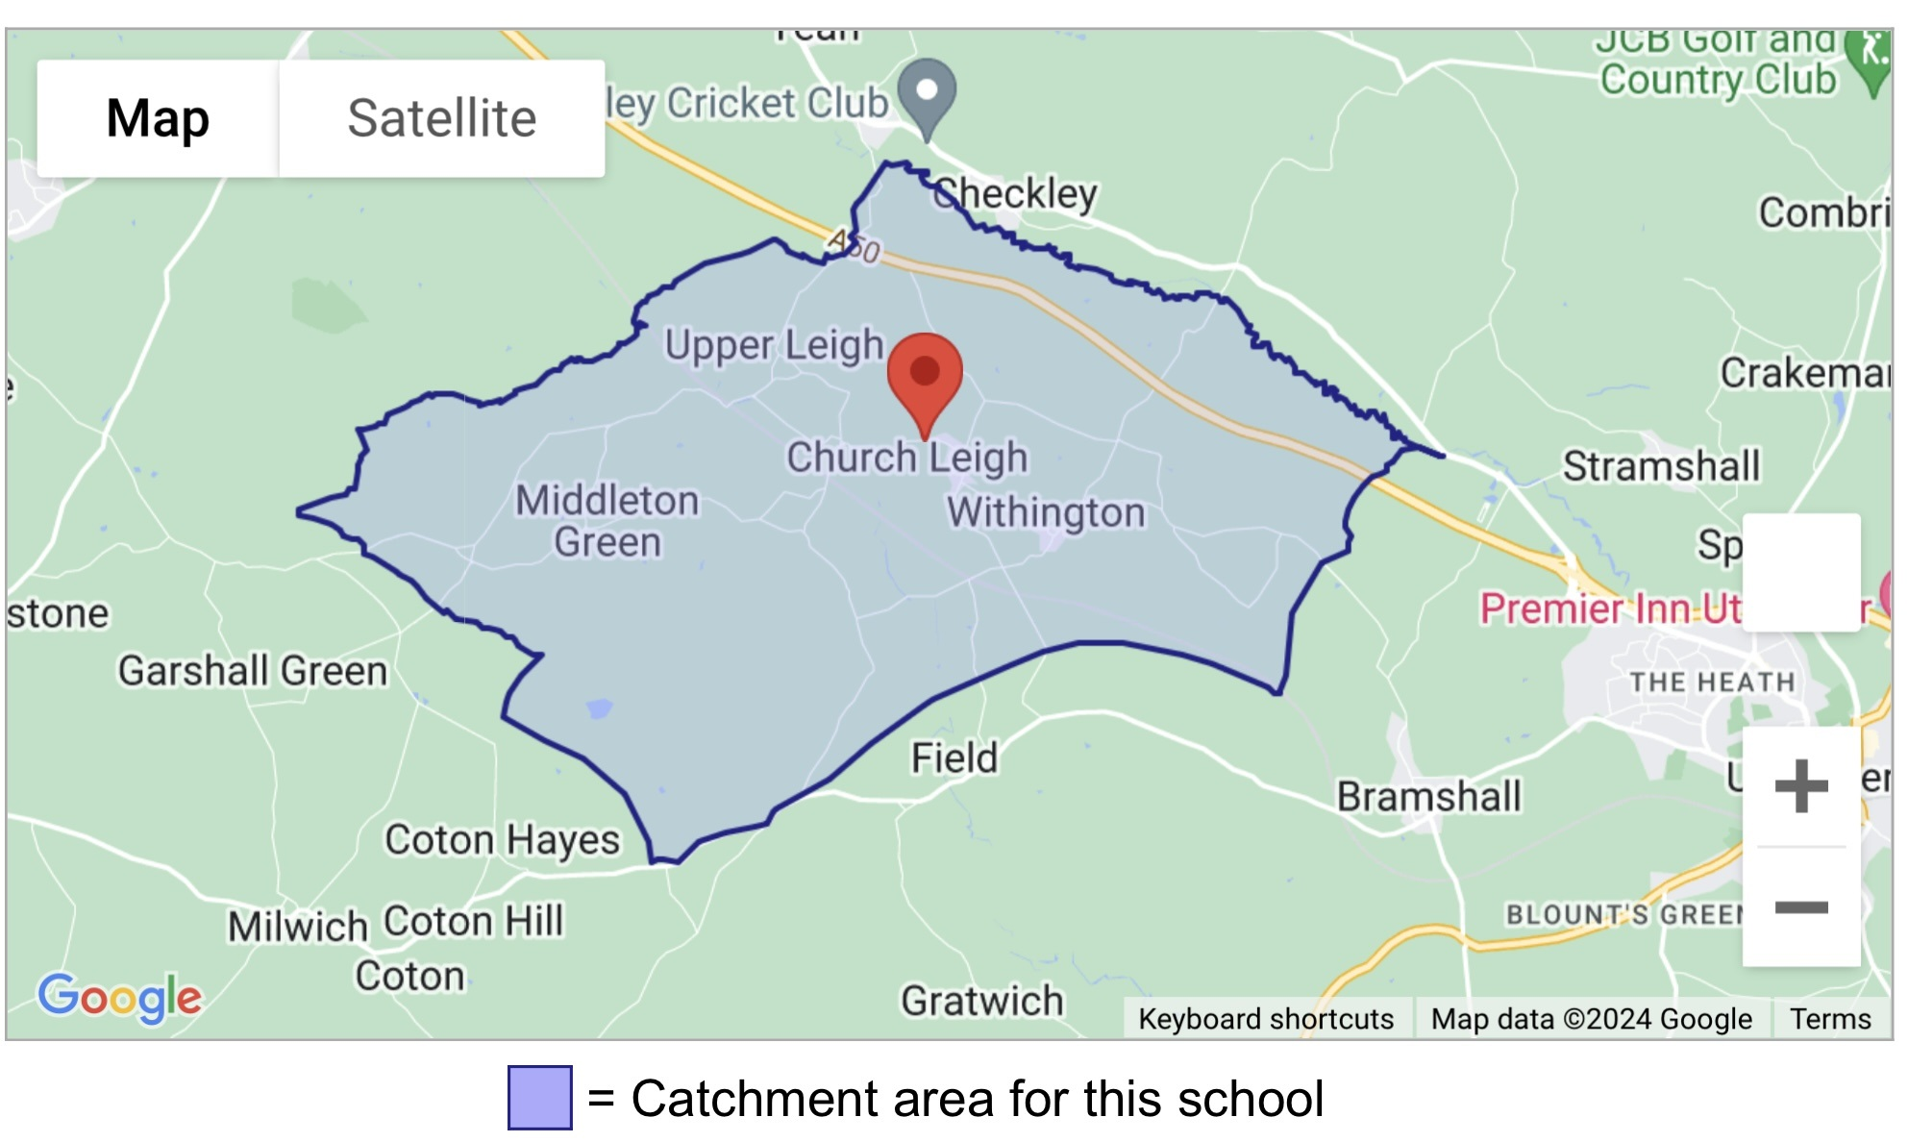

The home address is considered to be the child’s along with their parent/carer’s main and genuine principal place of residence at the time of the allocation of places i.e. where they are normally and regularly living. If a child is resident with friends or relatives (for reasons other than legal guardianship) the friends or relatives address will not be considered for allocation purposes.
If a child’s home address changes during the admissions process it is the responsibility of the parent/carer to inform the Academy immediately. Where there is a proposed house move taking place during the admissions process the Academy will only accept the revised address for purposes of allocation where parents/carers can provide documentary evidence of the move by 1 week before the closing date. It will be necessary for sufficient evidence of a permanent move to be provided by the applicant by this date before it will be taken into account for allocation purposes on the offer date.
If a place is offered on the basis of an address that is subsequently found to be different from the child’s normal and permanent home address at the time of allocation of places then that place is likely to be withdrawn.

Where parents have shared responsibility for a child, and the child lives with both parents for part of the school week, parents will be required to provide documentary evidence to support the address they wish to be considered for allocation purposes.
It is expected that parents will agree on Nursery places before an application is made, and it may be necessary to request evidence from you to confirm that this is the case. The Academy is not in a position to intervene in disputes between parents over Nursery applications and will request that these are resolved privately.
If there are a limited number of spaces available and we cannot distinguish between applicants using the criteria listed, such as in the case of children who live in the same block of flats or are the result of a multiple birth, then the child or children who will be offered the available spaces will be randomly selected. This process will be independently verified.
Appendix 2

A 'looked after child' or a child who was previously looked after but immediately after being looked after became subject to an adoption, child arrangements, or special guardianship order including those who appear [to the admission authority] to have been in state care outside of England and ceased to be in state care as a result of being adopted. A looked after child is a child who is (a) in the care of a local authority, or (b) being provided with accommodation by a local authority in the exercise of their social services functions (see the definition in Section 22(1) of the Children Act 1989).

Looked after children means children who are looked after by a local authority in accordance with section 22 (1) of the Children Act 1989 and who is (a) in care of a local authority, or (b) being provided with accommodation by a Local Authority in the exercise of their social services functions (see definition in Section 22 (1) of the Children Act 1989) at the time of making an application to a school. This includes children who were adopted under the Adoption Act 1976 (see section 12 adoption orders) and children who were adopted under Adoption and Children Act 2002 (see section 46 adoption orders). Child arrangements orders are defined in s.8 of the Children Act 1989, as amended by s.12 of the Children and Families Act 2014. Child arrangements orders replace residence orders and any residence order in force prior to 22 April 2014 is deemed to be a child arrangements order. Section 14A of the Children Act 1989 defines a special guardianship order as an order appointing one or more individuals to be a child’s special guardian (or special guardians). It is the applicant’s responsibility to provide any supportive information required in order for the application to be assessed against the published admissions criteria, the school will not seek to obtain this information on behalf of the applicant.

