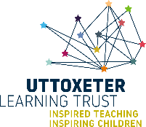

All Saints CE First School
Loving and learning with Jesus
“Let your light shine before you”
Matthew 5:16

Relationships and Health Education Policy

Our Vision

Loving and learning with Jesus
“Let your light shine before you”
Matthew 5:16

As a Church of England school and a member of the Uttoxeter Learning Trust, the teachings of Jesus and our Christian Values are at the heart of all we do, our children and staff serve with courage, compassion, aspiration and hope to live life in all its fullness allowing them to flourish and shine.

Our Mission

- FAITH: Providing an environment where Christian values underpin all we do, where worship flows into our learning and where all children appreciate the value of other faiths whilst being rooted in a Christian community. Trust

- LEARNING: Achieving high standards in learning by identifying and providing for the needs and talents of each pupil to enable them to achieve their potential. Service

- OPPORTUNITY: Providing opportunities for pupils to be curious, creative and inspired by taking part in a range of educational experiences, visits and extra-curricular activities. Courage

- UNDERSTANDING: Establishing a caring community which recognises equality of opportunity, diversity and raises awareness of moral values within a Christian ethos. Compassion

- RESPECT: Promoting high standards of behaviour and fostering a sense of respect and responsibility for self and others. Respect

- INDEPENDENCE: Helping children develop a range of skills to be confident and self-assured learners with excellent attitudes to learning. Generosity

- SELF-MOTIVATION: Fostering self-reliance, so that pupils enjoy the challenge of learning and are resilient to failure. Perseverance

- HAPPINESS: Creating a safe, nurturing and stimulating learning environment in which children can flourish. Friendship

Relationships and Health Education Policy

Policy Statement and Aims
At All Saints CE First School and across the Uttoxeter Learning Trust First schools, we believe that our ‘Relationships and Health Education’ provides children with the knowledge, skills and understanding they require to lead healthy, confident and successful lives to become informed, responsible and active citizens in our future society. We encourage learners to grow, develop and understand their self-worth through a structured Relationships and Health curriculum which aims to prepare them for life in an ever changing world.
“Today’s children and young people are growing up in an increasingly complex world and living their lives seamlessly including online. This presents many positive and exciting opportunities, but also challenges and risks. In this environment, children and young people need to know how to be safe and healthy, and how to manage their academic, personal and social lives in a positive way.”
Department for Education, 2019
The teaching of Relationships and Health Education incorporates the whole school ethos Loving and Learning with Jesus. This is embedded by incorporating these values into PSHEe and relationship and health education lessons across year groups but also in assemblies, break times, PE lessons and extra-curricular activities.
Furthermore, the relationship and health education lessons supports the wider work of the school by promoting self-affirmation and mental well-being by indorsing positive thinking which is already embedded within the school environment such as displays, ambassadors such as our well-being champions, PE lessons, wellness areas and circle times.

What is Relationship and Health Education?
Relationships and Health Education focuses on developing the skills, knowledge and attributes to keep children and young people healthy and safe and to develop good, strong relationships to prepare them for life and work. Relationships and Health Education is an OFSTED planned programme which aims to help children to fully develop as individuals and as members of families and social and economic communities. The goal is to equip young people with the knowledge, understanding, attitudes and practical skills to live healthily, safely, productively and responsibly in society.

Intent:
We aim that through the Relationships and Health Education curriculum our pupils will:
- Develop a safe and healthy lifestyle
- Understand what makes for good relationships with others
- Develop a whole school approach to building self-confidence and self esteem
- Develop skills in language, decision-making and assertiveness
- Learn to respect the differences between people and celebrate uniqueness
- Have opportunities to consider issues which may affect their own lives and the lives of others
- Develop good relationships with other members of the school and the wider community
- Develop their understanding of healthy and unhealthy relationships both on and offline
- Be offered learning opportunities above and beyond the curriculum
- Be prepared for the roles of adult life

Implementation:
- A school ethos that promotes self-respect and respect for others which values the place and contribution of all individuals to the school
- Circle time activities
- Friendship intervention groups
- Direct, cross-curricular and purposeful Relationships Education teaching across the school
- Teaching Relationship Education through other curriculum areas e.g. Religious Education, Science, computing, PE
- Outside agencies and guest speakers such as police officers, fire fighters, NSPCC
- Whole school events e.g. Anti-bullying week, Online safety Day, Charity fundraising events
- School Council meetings to discuss school issues
- Well-being champions

Impact
At All Saints CE First School we will monitor the impact of our Relationships and Health Education teaching through pupil questionnaires to see what children are learning and enjoying in their Relationships and Health Education lessons to get an understanding of what we can improve to best support our children and to help them grow into active and strong members of the community.

Children and Parental Involvement

At All Saints CE First School, children and young people are not simply being prepared to become citizens; they are already citizens both in their school and community. This is embedded through decision making opportunities such as voting for their School Council reps, House Captains, Sports Council etc.

Parents and guardians of pupils at Bramshall Meadows First School are also being encouraged to be involved with the development of the Relationships and Health Education policy to ensure that there is an awareness of what pupils will be taught in this subject area. The parental consultation will ensure that parents have an awareness of the subject coverage and how and when Relationships and Health Education will be covered in their children’s year groups as well as an opportunity to voice any concerns or questions.

Inclusion
The Relationships and Health Education policy aims to support all learners and their needs, as inclusivity is part of its philosophy. As with core subject areas, teachers will tailor lessons and resources to suit the needs of all children in their class to ensure that they work to achieve their full potential. All teachers will ensure that topics are taught with sensitivity, with a respect for backgrounds and beliefs of pupils and parents. Teachers will collaborate with families and health practitioners where needed and will plan for appropriate content matched to learners’ needs to ensure that teaching is inclusive. At All Saints CE First School we believe that it is in the best interests of the child to receive high-quality, developmentally appropriate Relationships and Health Education input that safeguards learners by teaching the skills and knowledge required to strive in an ever changing world both online and off. The understanding and attributes developed through the Relationships topics will then be used to support individuals right now as they are growing up, and also support them as they develop into adulthood and the working world.

How will sensitive issues be handled and delivered?
Sensitive and controversial issues will be delivered respectfully, taking into account a child or parent’s beliefs, values or religion. The purpose of the Relationships and Health curriculum is to enable children to address sensitive issues in a balanced and respectful way, in a safe environment. Teachers will ensure that any sensitive issues are taught in a careful manner with a focus on the needs of the children within their care. Teachers should:
- Ensure that ground rules are established regarding how they behave towards each other
- Ensure that pupils are clear about the difference between fact and opinion
- Provide appropriate support after a session for any pupil who may be upset following on from an issue raised in the lesson
- Not share or express their own views, bearing in mind that they are in an influential position within society
- Adapt and tailor lessons to support the needs of learners to ensure that the lesson is accessible for all

How will the issue of confidentiality be handled?
In the context of Relationships and Health Education lessons, children may disclose personal information. Children must be made aware that in this situation it is necessary for the teacher to act upon certain disclosures that a child may make if the teacher feels that it puts the child or somebody else in danger. Therefore, it is good practice for teachers to establish ground-rules before tackling any sensitive or controversial issues within their lessons.

Delivery across school
The delivery of our Relationships and Health Education will be conducted using discrete and cross-curricular learning opportunities. The resource, 1 decision will also be implemented to support teachers in the delivery of this subject area using real life examples and videos. Below is an outline of the Relationships and Health Education topic coverage.
KS1
Keeping and Staying safe
Keeping and Staying healthy
Relationships
Being responsible
Feelings and Emotions
Computer Safety
Money Matters
Hazard Watch
Fire Safety

KS2
Keeping and Staying safe
Keeping and Staying healthy
Friendships and Relationships
Dreams and Aspirations
Feelings and Emotions
Online Safety
Entrepreneur

Key skills developed through our Relationships and Health Education
Emotional literacy
Emotional literacy is the ability to recognise, understand, deal with and express emotions in an appropriate manner. Children need to understand the part emotions play in human actions and experiences so that they are able to support their peers as well as know how to handle their individual thoughts and feelings. In order to be emotionally literate, children need to develop the following skills:
- Recognising, naming and describing feelings
- Understanding and empathising with others
- Managing individual feelings
- Responding appropriately to the feelings of others
- Communicating effectively
- Be an effective and respectful listener

The opportunities provided in our Relationships and Health Education teaching enables children to develop these skills through well planned activities and circle times as well as supporting children’s mental well-being both now and in the future.
Working with others
The teaching of Relationships and Health Education incorporates and promotes the development of teamwork and social skills in order to develop children’s capacity to work collaboratively and effectively.

Problem solving
Well planned and effective Relationship and Health lessons should use appropriate real life situations relating to the topic covered in class. The resource, 1decision, uses videos containing real life scenarios. These provide children with a decision making opportunity and the learners must discuss, use thinking skills and problem solve to reach the best outcome.

Monitoring and assessment
The delivery and implementation of our Relationships and Health Education will be monitored by the Relationships and Health Education Leader to ensure that all pupils receive high quality teaching to certify that they are fully prepared for future study, work and the wider society. Evaluation of the curriculum’s effectiveness will be conducted through pupil questionnaires, interviews, staff meetings and lesson observations. Pre and post assessments will be conducted for each topic covered throughout the year to monitor how pupil’s understanding has been impacted and benefited during a module of study. As well as use of assessment for learning (AFL) during the topic to ensure that teachers can track pupil’s progression during the course of a module.

Bramshall Meadows First School pupils involved in decision making opportunities?
The Relationships and Health Education embeds the delivery and promotion of the British values:
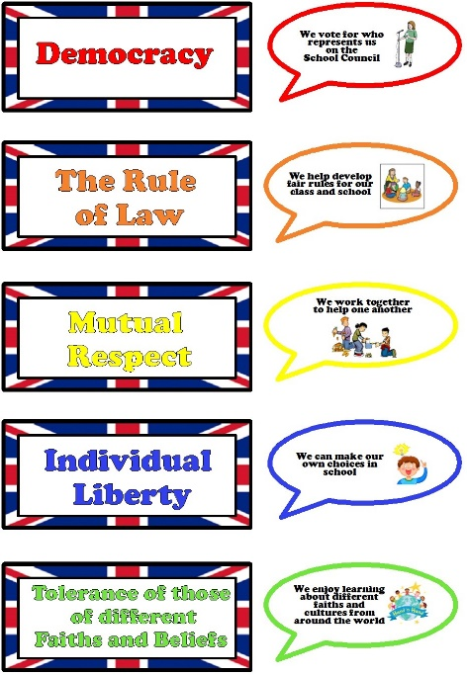
- Democracy
- The Rule of Law
- Mutual respect
- Individual liberty
- Tolerance

These five values will be included in the delivery of Relationships and Health Education lessons across the school as well as promoted in the school environment such as voting, Religious Education lessons, school rules, classroom rules and the School Council.

Role of the Relationships and Health Education Leader
The leader ensures that there is well-planned and effective Relationship and Health education at All Saints CE First School. This will be conducted through pupil and staff questionnaires, pupil interviews, learning walks and book trawls. The leader is not responsible for assessing every pupil, but will manage a whole-school approach to the assessment and provision of our Relationships and Health Education.
How is staff’s teaching of Relationships and Health Education developed?
Opportunities to develop the teaching of Relationships and Health Education at All Saints CE First School is conducted through assessing the needs of teachers within the school and planning staff training opportunities to support these needs. Training sessions and courses from outside agencies also enable teachers to develop their pedagogy to support the teaching and learning of pupils to ensure they receive the best Relationships and Health Education possible.

This policy should be read in conjunction with our schools Behaviour policy, Online Safety policy, Anti-bullying policy, Safeguarding policy, SMSC policy, Fundamental British Values policy and Physical Education policy.

